**MODULE 1 – EV in Energy Transmission**

Final Module Quiz

**Questions for Section 1.1**

### Question 1 Well-to-wheel emissions of EV powered by wind/solar energy is...?

1. Higher than that of EVs powered by electricity from coal power plants.
2. Higher than that of vehicle with an internal combustion engine.
3. Virtually zero.

Ans. C

### Question 2 Energy use of an EV to drive 100 km is compared to gasoline vehicles with combustion engine ...

1. Similar.
2. Much lower.
3. Higher.

Ans. B

### Question 3 Compared to cars with internal combustion engine, electric cars...

1. Do not normally have multiple gears in the transmission.
2. Are much lighter in weight.
3. Have a lower tank to wheel efficiency.

Ans. A

**Questions for Section 1.2**

### Question 1 Please have a look at the graphic below. You have seen it previously during the lecture.

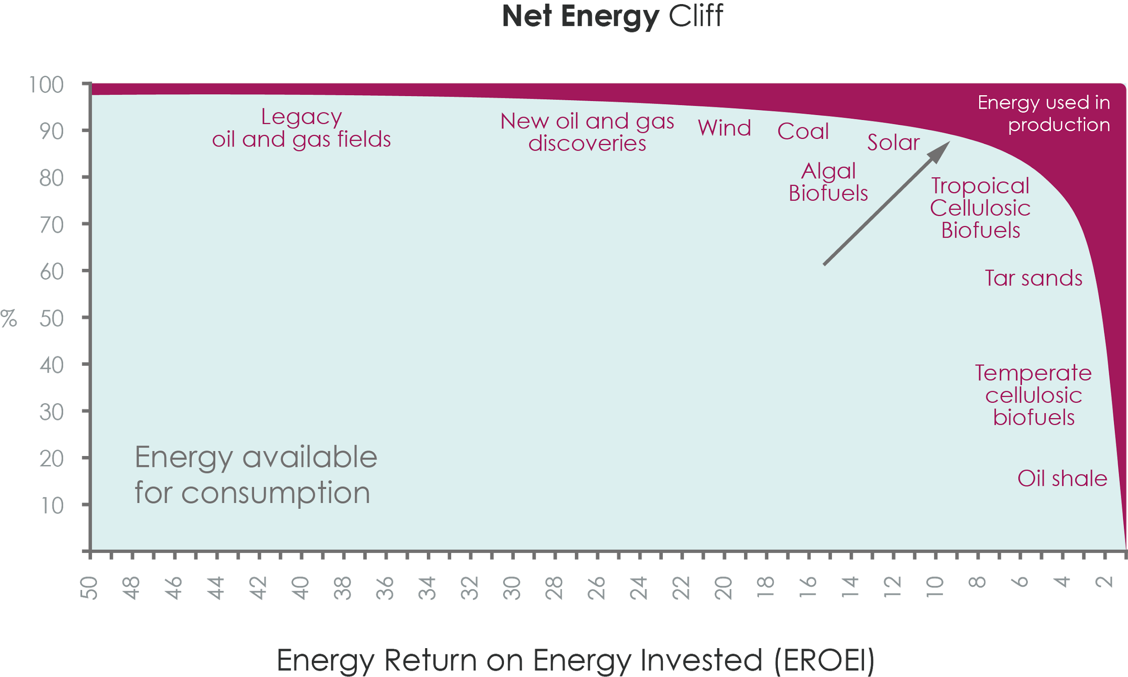

**Question:** What does the arrow represent in the curve of the image above? What is the significance of the arrow?

1. The arrow is indicating the Energy Return On Energy Invested (EROEI) needed to support modern industrial societies. This point is just before the so called ‘net energy cliff’. Passing this cliff is very risky for economy.
2. The arrow is indicating the ‘Net Energy Cliff’. The significance is that passing this cliff is very risky for economy.
3. The arrow is indicating the maximum level of energy that industries are allowed to consume. The significance is that beyond this energy return on energy invested is very less.

Ans. A

### Question 2 What are the advantages and disadvantage of using Electric Vehicles?

1. The advantage of electric vehicle is that the driving range is less due to small battery size and the disadvantage is the high waiting time for charging.
2. Electric vehicles are the only solution for local zero emission traffic and, their driving costs are very good. The disadvantage is that the driving range is limited due to battery size and waiting time for charging.
3. Electric vehicles are cheaper than conventional vehicles and therefore, people can afford it easily. The disadvantage is that electric vehicles cannot create an emission free traffic in the cities.

Ans. B

### Question 3 Take a look at the graphic below named 'Raw Energy Contribution EV and ICE'. It has been previously presented on a slide in the previous lecture.

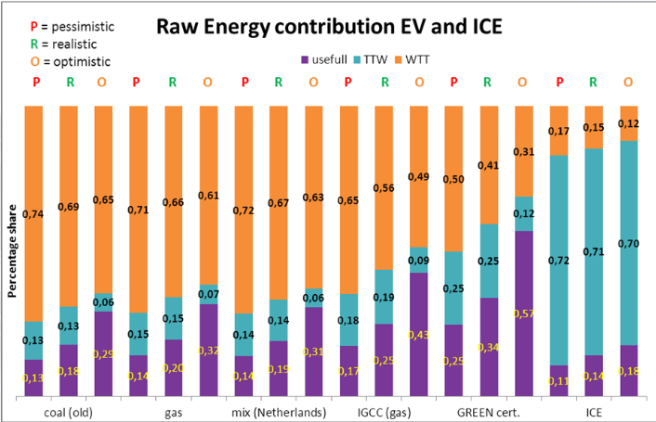

Based on what you have previously learned during past lecture, please answer the questions 4 and 5.

What do the colors orange, blue and purple represent in the diagram?

1. Orange part represents energy losses. The blue part is the production of fuel. The purple fragment is the useful energy that hits the road for driving.
2. Orange part represents production of fuel. The blue part is the energy losses. The purple fragment is the useful energy that hits the road for driving.
3. Orange part is the useful energy that hits the road for driving. The blue part is the energy losses. The purple fragment represents production of fuel.

Ans. B

### Question 4 In the above figure, which energy source has best average well-to-wheel efficiency?

1. Mix (Netherlands) has the best average well-to-wheel efficiency.
2. IGCC (gas) has the best average well-to-wheel efficiency.
3. Green certificates which is electricity based on renewable energy has best average well-to-wheel efficiency.

Ans. C

**Questions for Section 1.3**

### Question 1 The transition from IC engines to electric cars will have a wide-ranging impact on a country's economy. Which of these sectors of the economy are likely to be affected?

1. Electricity infrastructure sector
2. Information and Communication services
3. Petroleum industry
4. Automotive industry
5. Logistics and transport industry

Ans. ALL

### Question 2 Governments intervene in the transition to electric mobility with the aim of...

1. accelerating technology development and electric cars adoption
2. creating new jobs
3. improving air quality in cities
4. meeting national climate policy goals
5. maximizing its revenues
6. promoting interests of electric car companies

Ans. A, B, C, D

Question 3 Which of the options below are possible obstacles in the transition to electric based mobility?

1. Technology
2. Vested interests of existing actors
3. Charging infrastructure
4. User behavior and habits
5. Electricity infrastructure

Ans. ALL